**COSC-2083 Introduction to Information Technology**

**Semester 10/2021 - 1/2022**

**Lecturer: Nguyen Minh Long**

**Our IT project**

**Jeff the virtual assistant**

**A Report by group 6**

Table of Contents

1. Team profile 3

1.1. Team name: 3

1.3. Group processes 8

1.4. Career plans 8

2. Tools 9

3. Project Description 9

3.1. Overview 9

**3.1.1. Topic** 9

**3.1.2. Motivation** 10

**3.1.3. Landscape** 11

**3.2.1. Aims** 12

**3.2.1. Goals** 12

3.3. Plans & progress 13

**3.3.1. Initial idea** 13

**3.3.2. Current idea** 14

**3.3.3. Future plan** 14

3.4. Roles 15

3.5. Scope & limits 16

**3.5.1. In-scope features** 16

**3.5.2. Out-of-scope features** 16

3.6. Tools & Technologies 17

3.7. Testing 20

3.8. Timeframe 21

3.9. Risks 22

3.10. Group processes & communication 23

4. Skills & jobs 25

4.1. Front-end developer 25

4.2. Back-end developer 25

4.3. Database administrator 26

4.4. AI & Machine learning expert 27

5. Group reflection 28

5.1. Trinh Viet Quy 28

5.2. Nguyen Thi Ha Giang 28

5.3. Tran Khanh Duc 28

5.4. Nguyen Tuan Thang 28

# **Team profile**

* 1. **Team name: SKYNET**

-Our team decided to go with the name Skynet. The reason behind this is because our project is to create an AI-machine learning virtual assistant. We believe that AI will be the technology that will dominate the industry in the near future. As developers, we wish to be the pioneers of this field. In pop culture, there is this popular movie where a tech company created an AI that is so smart and advance that it can calculate then travel time to terminate anything that is a threat to the future. That movie was Terminator and the name of the company is Skynet. We thought to ourselves, what better name can we choose for this group other than Skynet.

* 1. Personal information

1. Student number: s3915202
2. Role: Back-end developer

s3915202@rmit.edu.vn

0123456789

Contact

South Saigon Campus



“I was born and raised in Hanoi. Ever since I was a child, I have been remarked to be extremely curious. I often hide adults from taking apart electronics in the house to find out how they work inside and then putting them back together. When I was a little older, I was exposed to a computer and was immediately captivated by what it could do especially with video games where I could interact with non-player characters. One day, I was watching a robot cartoon called Wall-E, once again my passion for technology was aroused, at that time I wished when I grew up, I could create a robot with a conscious and perception as a human being. After 2 years of studying, I realized that was not really the major I wanted to pursue. I suddenly realized that what I want to create is not a robot, but the brain of that robot. In order to achieve that goal of mine, I decided to study information technology to learn how humans can teach computers and how computers interact with humans.”

*Trinh Viet Quy*



s3914108@rmit.edu.vn

0123456789

Contact

South Saigon Campus

“I was born and grown up in Ho Chi Minh City. During my time in Secondary Highschool, I had a chance to experience Pascal Programming. From there, I realize that information technology is a powerful tool that can solve many math problems with just some simple lines of code. Ever since I know about gaming and web surfing, I have always wondered how they are programmed.  I wanted to program games, application as well as websites for myself so I decided to study IT. Personally, I have taken a Front-end course therefore I have some experience in Java Script and CSS to create basic websites base on my knowledge of designing and programming. However, my back-end development skill is still not sharpened so I have a lot to learn. Additionally, I am taking a French course which I think might be useful for my future career. Beside from that, playing guitar for me is an excellent way to relief the stress after a long period of studying and cooking for the family is another passion of mine. Moreover, in order to achieve my goal of being a professional game/web developer, I have a habit of reading books about life and developing skills as a way of self-development”.





1. Student number: s3914108
2. Role: Front-end developer

*Nguyen Thi Ha Giang*



1. Student number: s3907087
2. Role: Reporter/Editor



“Similar to our front-end developer, am also born and raised in Ho Chi Minh city, Vietnam. However, I come from a mixed culture family because my ancestors were from China. Being born in a strict Chinese family, I have developed a sense of responsibility and hard-working attitude toward my goals. But I love playing games, it just every boys passion. Back in the days, my cousin, who has been a specialist in IT for several years now, usually came to my house and showed me some hacking tricks for the game, he even helped me cracked the wifi passwords of local neighbors, which was very cool. I then thought to myself, IT was so astonishing and have so many potentials in the future, so I developed the passion ever since. I still have long way to go since I just finished learning about the basic concepts in IT, but I am eager to learn more. During school times, I am focused and determined but in my free time, I enjoy doing various sport activities as way to keep my head cool and my body strong. I also enjoy reading new research papers to update my knowledge on things happening around the world and what new technology that should be minded in order to keep up the trend.”

South Saigon Campus

Contact

0932039420

s3907087@rmit.edu.vn

*Tran Khanh Duc*

“I was born in a small village in Hai Duong, Vietnam.  After graduation in high school, I went to Ho Chi Minh City for studying in the university. In IT field, I am really interested in programming which is about building games. When I was in Highschool, I used to change values in games data so that the money would increase, which were really fun experiences for me so I developed an interest for IT since. I have had basic knowledge about Python and had tried creating my own games, but they are still under development and I still have a long way to go. In my free time, I often do part-time jobs, social activities and enjoy my time at the Taekwondo club as well as playing the guitar to relief school stress. For example, I took part in an outside bonding with my club which is Taekwondo. One time, we even went climbing with the whole club. It was a memorable day for me because we try so hard. In the end, we managed to get to the top. The feeling was very proud and relief because I had finally achieved the goal of that day. One day, I will reach the peak of my dream and become a great game developer.”

South Saigon Campus

Contact

0123456789

s3877039@rmit.edu.vn

1. Student number: s3877039
2. Role: UI/UX designer

*Nguyen Tuan Thang*

## **Group processes**

-Overall, the team works well together. Each of the members is very responsible and reliable. We always try our best to finish our tasks before deadlines so that we have more time to review our work. Moreover, everyone is very supportive toward each other. If one member finishes his/her task, he/she would voluntarily help other members who are still working on their tasks. Because of this, we work very effective and fast. However, the members still have differentiations so sometimes, we have disagreement during our work. Despite that, we are very thoughtful toward each other and try our best to take into consideration the proposals of other members and create the final products that we all feel satisfied about. In the context of the project being extended and we are invested to create the saleable product, the team would have to find a way to communicate more and set up offline meetings so that features could be planned thoroughly.

## **Career plans**

|  |  |  |  |  |
| --- | --- | --- | --- | --- |
|  | Quy | Giang | Thang | Duc |
| Ideal job | Software engineering (artificial intelligence application developer) |  | Web developer | Software Developer |
| Workplace | Creative, inspirational, flexible, active. |  | Comfortable, innovative and motivating | Flexible, modern and respectful |
| Working hours | Flexible time, ideal is 40-50hrs/week. |  | 8hrs/day | 8hrs/day |
| People |  |  | Sociable, supportive and enthusiastic in the work. | Interactive, Friendly, supportive and respect toward each other. |

1. **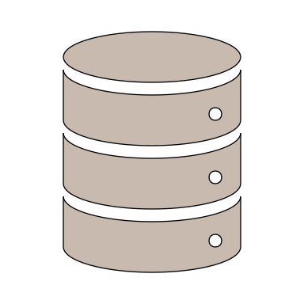****Tools**

https://vnesetalkingbush.github.io/IIT_asm_3/

https://github.com/VNeseTalkingBush/IIT_asm_3

# **Project Description**

## **3.1. Overview**

### **3.1.1. Topic**

For some people, time is as value as gold. There is too much work to do while time is limited. Hiring an assistant seems to be an amazing way to share the workload and boosts productivity. However, it is not easy for an employer to find the perfect assistant who can keep up with the workflow while at the same time, understanding the employer’s need and still able to maintain productivity. Not to mention, hiring an assistant also means the employer has to pay them salary like any other employees. In today world, when technology gradually replace human in many fields, virtual assistant is a new way for the busy businessmen to keep track on their work as well as function like any other real assistant. Despite that, virtual assistant seems to be a new and strange concept for the people of Vietnam, many claims that they are not familiar with the technology and does not know the supported language to interact with the assistant. Understanding these difficulties, in this project our team challenged ourselves to create a virtual assistant that can solve these issues.

Most available assistant today, such as Cortana or Siri operates on a very high level of technology, too advanced that many users cannot understand the concept and the functions of it. What we did with Jeff was removing all the unfriendly functions of other virtual assistant and give him basic functions and commands so that newbies to technology would understand and can use Jeff as their first step to get familiar with the concept of virtual assistant. Jeff is capable of basic tasks such as searching with voice input, schedule and remind the users for the meetings, calls as well as texting, creates timers, etc. All of these functions can be operated by voice command and the supported language will be Vietnamese. We hope that Jeff can be the first step for Vietnamese people to get familiar with applying technology to their daily life. After getting familiar with Jeff, the users would have knowledge to upgrade his/her assistant to a more advance system according to their needs. Of course, there are still many rooms for Jeff to get improved and enhanced. However, the nature of Jeff will still remain a basic virtual assistant that functions fundamentally and act as the first steps to get into the vast world of technology.

### **3.1.2. Motivation**

We noticed a fact that when people around the world are adapting to the rapid change of the technology world, the Vietnamese still struggle to get familiar with 4.0 technologies. Voice assistant is not a new concept, in fact, the first virtual assistant was introduced in the early 90s by IBM and it was called “Simon”. It was not until October 2011 that Apple commercialize Sire – the first advanced and commercially used virtual assistant. Since then, people around the world have been adapting with this technology and apply it to better their daily life. Despite there are many advanced voice assistants available with AI and self-learning technology, most Vietnamese people forget that they exist on their smart devices. This is because these assistants are not capable of Vietnamese language and is not fully optimized for local information and localization.

Understand these issues and wish to create a product that is “by Vietnamese and for Vietnamese”, we have this idea of creating Jeff – a Vietnamese friendly virtual assistant to solve these issues. We create Jeff with the purpose of creating a convenient, smart and friendly way for users to interact with their device. Not only that, we build Jeff as basic and easy to use as possible because we want Jeff to be peoples’ first virtual assistant and Jeff would act as a means for them to get familiar with the concept of virtual assistant before the move on to more advance system. Especially, when the pandemic is happening and people have to work from home, Jeff can be a good way for people to boost their productivity and enhance their work from home experience.

### **3.1.3. Landscape**

In fact, we are not the first group of people to think of this idea. There are a few honorable names that is worth mentioning but the biggest competitors are the virtual assistant called KiKi developed by VNG and Viettel Cyberbot developed by Viettel. Both of these companies are big giants when it comes to the technology field in Vietnam. However, what make Jeff distinguished from these 2 is the fact that Jeff was built for basics usage. Which means that Jeff will so easy to use since he only has the basic functions such as searching, planning schedule, set timer, etc. These functions will be activated with basic command lines that will be short and easy to learn. Jeff is different from the rest because he is not meant to be advance and capable of intelligent tasks, Jeff is meant to be basic and easy to use so that users get familiar with the technology and can move on to higher system when they feel they are ready.

**3.2. Detailed description**

### **3.2.1. Aims**

As citizens of Vietnam, we understand that our country is still under developing and have to go through various difficulties in order to integrate with the world. Still, we believe that because we are small and young, our country has great opportunities to grow stronger and more advance. Vietnam is on our way to acquire the essence of technology. However, we still lack tools to make this process easier and more efficient. That is the reason why our team decided to create Jeff as a tool, a starter kit for people to get involve into the technology of virtual assistant, letting them experience the convenience of having a system supporting their business and daily life. As a starter kit, Jeff is meant to be the first virtual assistant that people from all ages can use. With simple lines of command and basic functionalities, Jeff will teach the people fundamental concept of virtual assistant and how to interact with them. After the users are familiar enough with Jeff, they would have enough knowledge and experience to move to a higher system to enhance their work even more.

In the near future, everything will be command by voices and the tasks will be carried out by the robots and AI, it is important that Vietnamese people get involve in this technology from the beginning. We hope that with our humble creation, we would solve the language barrier and closer the technology gap so that Vietnamese citizen can get familiar and enjoy the convenience of a smart system being applied to their daily life and/or business.

### **3.2.1. Goals**

**1. User friendly UI/UX**

Our goal with Jeff is to make it easy to use and users friendly, so we would design it as simple as possible. The user interface will be minimal with only Jeff avatar, chat box between users and Jeff, and a button to input voice command. Jeff’s will appear on the small corner when he is activated. When not in used, Jeff will enter sleep mode, which means it would still be working under the background and will response immediately upon calling. The users experience would also be a crucial goal for us when developing Jeff. We tried our best to create Jeff simple from inside to outside. Jeff’s source code was written very simple so that he has faster response time but still guarantee the accuracy of the result. We believe this would give the users great users experience.

**2. Basic command lines**

To keep the program simple and users friendly, the teams has put a lot of work in thinking about command lines. We had to think of the variety of commands that users would use since different tasks means different commands, while at the same time, commands format has to be uniformity so that Jeff can recognize the commands and carry out the tasks. In the end, our team has planned, unified and developed a unique set of commands that is both easy for the users to learn and remember as well as having a solid format so that the system can recognize them.

**3. Accurate results**

Accuracy is also a very important aspects of a virtual assistant. Understanding this, our team put more attention this part of code. We have programmed Jeff in a way that he would only do basic tasks such as searching with internet, playing music and other fundamental tasks and because of this reason, Jeff does not have to process a lot, all it has to do is browsing through the data source and find the most relevant results. We will also set Jeff’s default browser as google.com so that the accuracy of the results will be guaranteed.

#### **4. Variety of data sources**

Even Jeff is designed to be a basic helper, we still want him to have wide range of knowledge. We will link Jeff with many data sources such as spotify, Wikipedia, youtube, etc. In the future, Jeff’s data sources will be updated and added more so that he would have more knowledge and users can interact more with him.

## **3.3. Plans & progress**

### **3.3.1. Initial idea**

At the beginning of the project, each member of the team had different project ideas because assignment 1 was individual. However, assignment 2 required us to create a team and work together on a project so the team had to choose out 1 idea among the member. At the time, each of us had ideas but it was very unclear. Among all, Quy’s idea proposal was very outstanding. He had a very clear thought about creating AI and how to build it. So, at first, our goal was to create an AI virtual assistant which is capable machine learning. In order to do that, we had to find the relevant source code for the AI part of the assistant and another source code for machine learning. After that, we had to think of a way to inject these two into the system combining so that they work fine together. That was a fairly challenging tasks that we managed to do. However, the biggest and most challenging problem arise when we almost done with building a workable code was that in order for the AI and machine learning systems to work properly, we need huge amount of users data so that the machine have some sort of data that it can learn at the beginning. This made us realize how small and unskilled we are and the fact that we are just freshmen in the IT fields, this project seems to be way to overwhelmed for us to carry out.

### **3.3.2. Current idea**

As the project keep on going, we had to think of new idea that we can actually carry out because we believe that is the real reason behind this project. It is not important how complicated the project is, it is how we think and create the project. So, after a few meetings, we decided to simplify our initial goal. Although our plan still remains creating a virtual assistant that is meant for Vietnamese people, the path we choose is very much different from the beginning. We began to think of how users in Vietnam use virtual assistant that is include on their smart device and we realized that, most of the users, including us does not find the virtual assistant feature helpful. It is not because these virtual assistants are useless or failures, but we just don’t have the need for using it. Rather than speaking in English and waiting for the system to response according to the internet speed, sometimes the results are not even close, we can just search manually by typing a scrolling. With this concept in mind, we believe it is crucial to have a system that is both easy to use, friendly with Vietnamese people and can act as a way for people to get familiar with the technology. That is when our idea of Jeff started to actualize.

### **3.3.3. Future plan**

In order to keep Jeff simple and easy to use as well as users friendly, we had to remove a lot of advance feature that is normally considered valuable on others virtual assistant. For example, we had to remove AI and machine learning features to simplify Jeff developing phase and we had to limit Jeff’s functions so that it remains users friendly and easy to use. If Jeff is approved and invested in the future when we graduated and become professional IT, we could create an upgrade version of Jeff, maybe we will call it “Jeff+” or “Jeff pro max” which we will add these features and upgrade Jeff’s overall UI/UX as well as the back-end code for a smoother experience. But at the time, our goal with Jeff is still simple and will follow the current plan.

## **3.4. Roles**

|  |  |  |  |  |
| --- | --- | --- | --- | --- |
|  | **Team members** | | | |
| Quy | Giang | Thang | Duc |
| Role | Back-end developer, team leader | Webpage developer | UI/UX designer | Reporter |
| Description | In this project, Quy is the leader of the team, Quy main job is to give and manage the tasks to other teammates. Quy’s was also given the task to collaborate with Thang to create the product. Since the product is fairly simple so Quy is responsible for the whole back-end coding. He is also in charge of debugging the product. | As the webpage developer of the team, Giang’s main job is to collaborate with Duc to create the content for the report. Giang is in charge of designing and adding the content from the main report to the website and make it more appealing to the readers. | Thang is in charge of developing the overall appearance for the project. He also required to collaborate with Quy, the back-end developer to create the user experience for Jeff. He would also need to update Jeff if Quy found a bug and debugged it. | Working as a reporter, Duc’s job is to plan out the content, do research and write the report for the whole project. He would need to paln out the idea with Giang, the web developer to create such content that would fit both formats. |

## **3.5. Scope & limits**

### **3.5.1. In-scope features**

1. **Access data sources on the Internet**

From having access to online data stores integrated in virtual assistants, users can save time at work, instead of having to search directly, virtual assistants can help users search. Information from online data warehouses such as Wikipedia dictionary or weather information, etc... virtual assistants will automatically summarize information in a concise manner and respond to users with necessary content.

1. **Multi-media function**

Not only supporting users in their work, we want our VA to also be able to help users in entertainment activities such as listening to music or videos, that's why we have integrated the function of playing music on the application. Search and play videos on the network by different connected devices.

1. **Communicate and understand the commands**

The virtual assistant has the ability to hear and understand the user's simple sentences. from there it can perform commands as well as communicate with users at a basic level.

1. **Text area**

In order to track the conversation history of the command, we have integrated the text area into the user interface. This makes it possible not only to better monitor VA, but also to support use in environments where quiet is required or where the sound system cannot be used.

1. **Function button**

Although it is very convenient to use commands or communicate with the shirt assistant by voice, in some cases, manual buttons are still necessary. We want the user to be able to issue commands to the virtual assistant by typing commands or pause the device so that it doesn't pick up unwanted sounds in certain environments or simply use the voice is not appropriate in some cases.

1. **Multi environment**

Although not really perfect, but the user interface created in our project can still run on some popular operating systems such as MacOS, Windows or Linux... This helps access to a wide range of users as well as more convenient support for users who work with many different computer operating system environments.

### **3.5.2. Out-of-scope features**

Because the project we chose required a huge amount of knowledge, our team are all newbies, it was extremely difficult to create a fully functional VA. we encountered a lot of limitations in building the app.

1. **AI natural language processing:**

This took a lot of time to build and load the language data for the software, with limited knowledge, we couldn't achieve the desired goal, however, the VA was still able to communicate and interact in simple sentences with users

1. **Programming language:**

Limited knowledge in programming languages ​​has limited us from creating the app we want. for almost every function of VA we have to learn new knowledge and the code doesn't always work. so, we had to omit many functions as set out in the plan and keep only the functions that can work relatively well.

1. **Machine learning function:**

The unexpected thing in the initial plan to design a VA application that has the ability to learn is the algorithms. This requires a lot more in-depth knowledge than we thought. Not only that, to test the learning ability of virtual assistants also requires a lot of practical time as well as input data sources. that's why current ML will still be a successor or in the future which my team can't immediately adopt right now.

1. **License/ access right:**

Licenses and access rights are also a difficult part of the project. it is a prerequisite for the VA software to be able to access and control not only the device, the applications within the device, and the available data sources. Not all sources are open so we can only give VA access to free open-source sources to the best of our knowledge such as Spotify, Wikipedia, and weather forecast…

## **3.6. Tools & Technologies**

1. **Pycharm**

During this project, our choice of programming language was Python since Python has many advantages such as simple commands, fast and powerful, huge community and library. In order to exploit Python potentials, we decided to use Pycharm, which is an IDE for Python developers. This software however, required the users to pay for it if they wanted to use the full features. However, lucky for us, RMIT university was generous enough to grand all IT student access to the school Pycharm service so we did not have to pay for the software but can still enjoy such a powerful tool.

An illustration of Pycharm use. Source: personal device

1. **Github**

Any projects need a repository in order to save and keep track of the overall developing process of the project. We decide to use Github because it is the most common repository available. Github has many advantages to offer to their users. It is free and the storing amount is more than enough for us to store our data. Rather than storing on a personal device, Github allow us to use the miracle of internet. Users just need to push their work on to their server, the server will store it on their cloud systems with the level of information security depends on how users set it to be opened source or closed source.

An illustration of Github. Source: our group’s Github page

1. **Tkinter (A python library)**

For interface design, we decided to use TKinter for numbers of reason. First of all, TKinter is simple to learn and use, it is the standard GUI of Python and we wanted to keep Jeff simple so TKinter is both simple and compatible with Python - our choice of programming language during the development of Jeff. Secondly, TKinter was included upon installing Python so we did not have to download anything

An example of TKinter usage. Source: <https://t3h.edu.vn/sites/default/files/vi-du-ve-python-tkinter.jpg>

1. **Vscode**

We choose VScode as an IDE for our webpage development. Giang - our front-end developer decided to use HTML, CSS and Java scripts to create the website. VScode was exactly what she needed because it is free to install, after installation, the users can used most of the available features that VScode offers. VScode also has huge community, thus, there many plugins to install and make her job easier. VScode overall interface is simple yet convenient and display necessary features to users. It is easy to use while learning.

An illustration of VScode usage. Source: <https://code.visualstudio.com/opengraphimg/opengraph-home.png>

## **3.7. Testing**

Testing is a crucial step for us before releasing the final product. We will first ask our friends and family to try out the initial products. They will try using the virtual assistant for a short period of time then report to us any problems such as bugs or misbehave functions. We will fix these issues then gather a testing group for further errors scouting. Finally, we will release the demo version to the public. Users from many places will give us their feedback on our products, we can then use these feedbacks to enhance our product gradually. After all the trials and demo are finished, it will be time for the official release of our virtual assistant.

## **3.8. Timeframe**

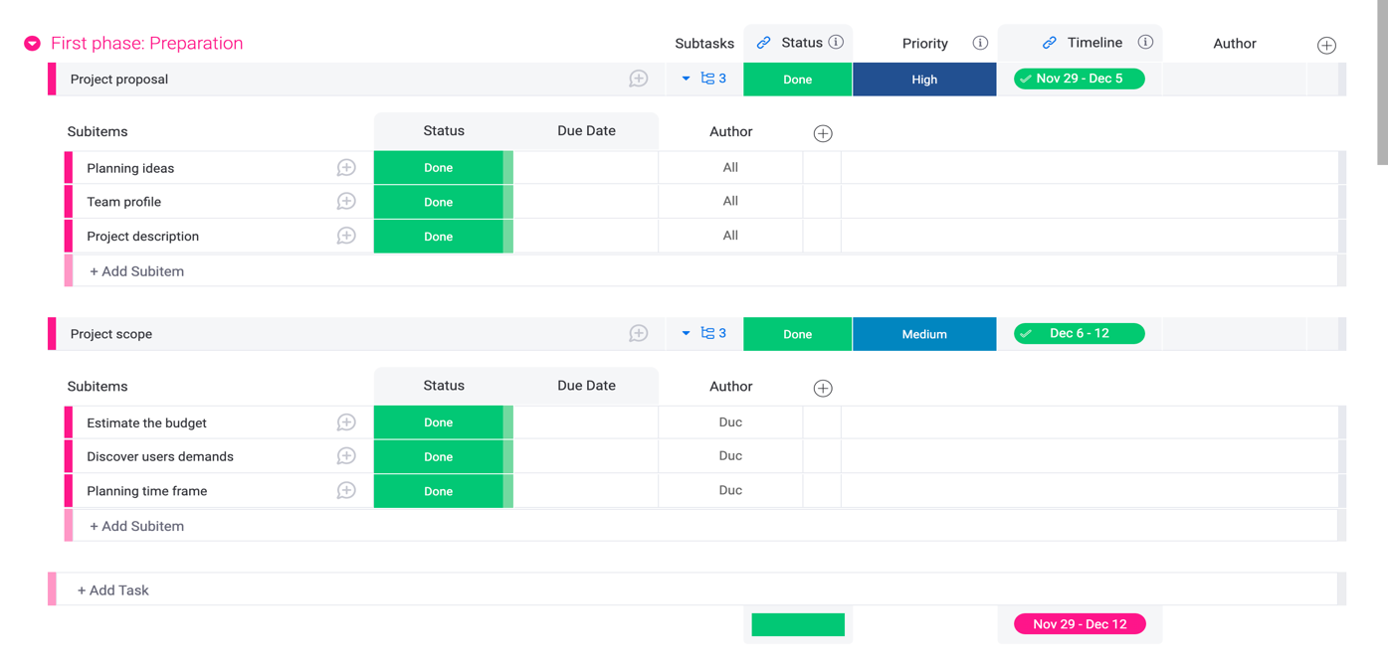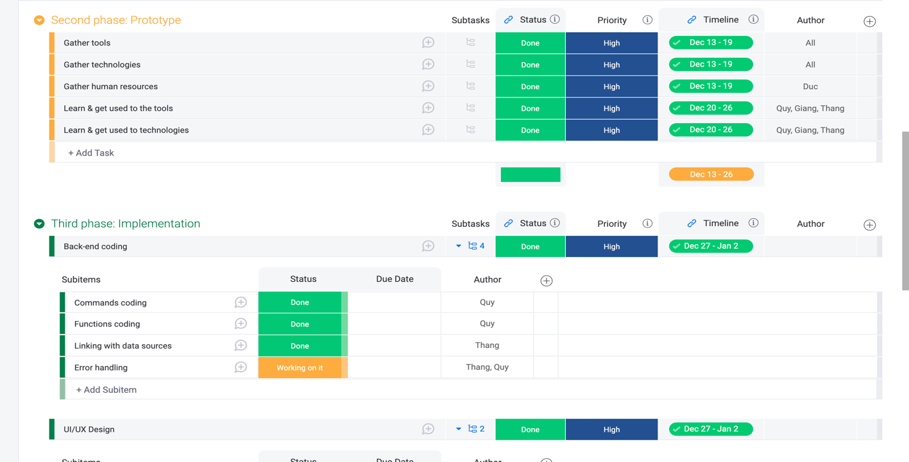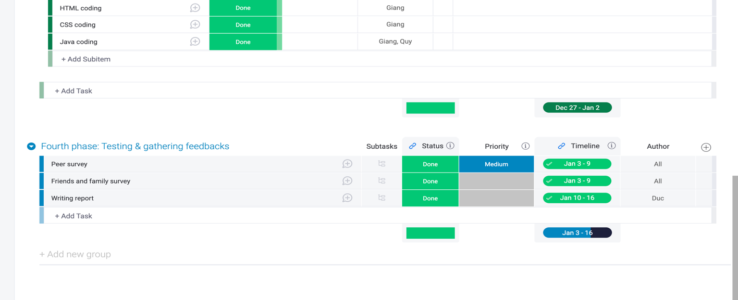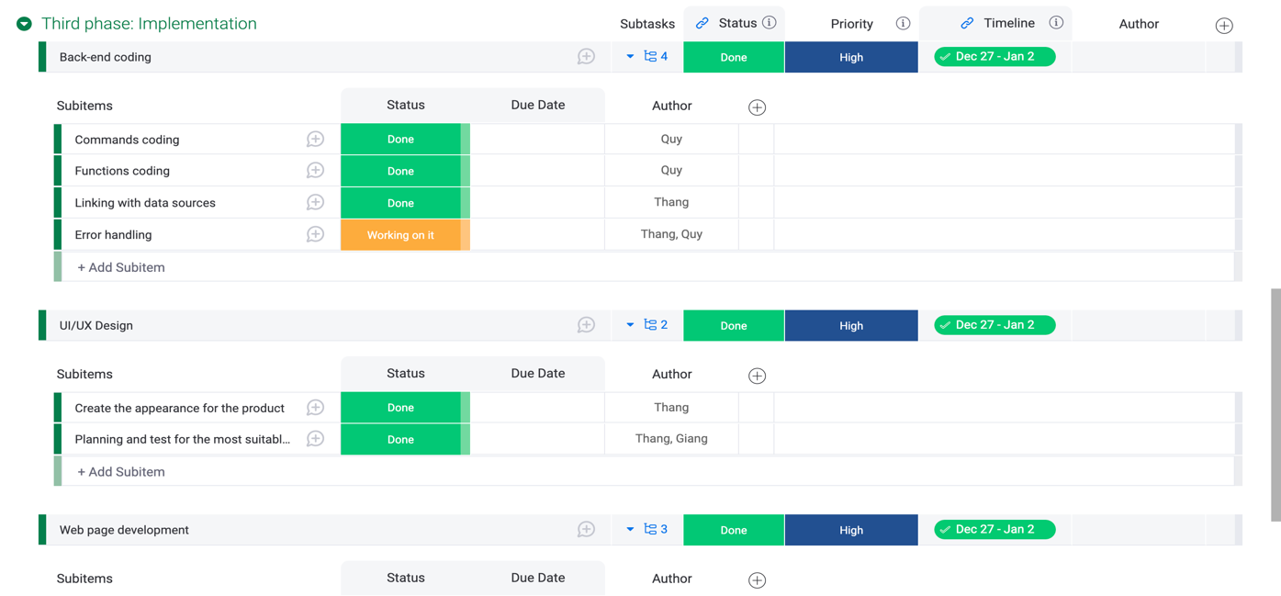

## **3.9. Risks**

There is no denying that nothing is perfect and easy to do according to the plan set out. It can be said that when we started the project, we encountered many difficulties as well as possible risks. Our idea is to create a virtual assistant application to interact with users and will help users to solve their requests easily. This project requires us to have a good understanding and solid knowledge of programming. We decided to choose Python for this project because Python is a very popular programming language.

1. **Technical difficulties**

The first risk we ran into was about the back-end code. In fact, there are a lot of open-source codes about virtual assistants shared on programming forums. However, the shared knowledge is quite extensive and professional, we have to learn a lot to be able to understand the algorithms well. The worry is that since we don't have much experience with back-end coding, our code may not be optimized and there will be a lot of out-of-control errors.

1. **Interface design difficulties**

We also encountered several problems while designing the interface for our product. Actually, before doing this project, we didn't have any knowledge about UX/UI programming for the app. After a while of researching, we decided to use Tkinter library of Python to design a simple interface. However, due to our lack of knowledge of interface programming, this was also a big challenge for us.

1. **Time management**

It is obvious that encountering bugs when coding is inevitable. This can slow down our workflow. Actually, finding and fixing bugs took a lot of time for us. And timing can also be seen as one of the biggest risks that can happen with this project of ours. Since we only had 1 month to work on this project, it can be said to be very difficult to complete the product properly.

The time limit is probably the biggest obstacle for us. While implementing the project, we almost did not have a solid knowledge to proceed, so learning while doing is a common occurrence. and with limited time, perfect project completion is impossible.

We did our best, but the risks such as code errors, code not running as expected, ... will all make our work stagnate. However, up to this point, we have also solved many of the above problems and can say that our product is partially complete.

## **Group processes & communication**

Since the beginning of this code was conducted online, we contacted each other via Facebook to introduce ourselves and get to know each other first. Since Giang, Quy, Thang has been working together since the last semester, it was no problem for them to communicate to each other. However, Duc is a new member so communication could be hard for him at first. However, he proved to be fairly sociable and did not have any problems with communicating. After getting to know each other on Facebook, we had to decide a workplace since not every information, data and files can be transmitted via Facebook messenger. We decide to use Discord as our main platform since it is very convenient and smart, by using Discord, we can devide chat rooms into individual sections for different types of files. For example, team rules can be put into “Welcomes and Rules” chatbox, general information can go in to “General”. Because of this, our tasks were display clearly so it was carried out very quick. We set a fixed 1-hour meeting on Friday every week to keep track on the process of tasks given to each member. To ensure the work are finished upon deadlines, Quy – the teamleader would reminds the members their tasks at the middle of the week, on Wednesday. If for some reason, a member is absent during that week meeting session, he/she must inform the group before hands and submit their finished tasks on the Discord dedicated chatbox for the team to look through later in the meeting session. If there are any issue, the leader would report back to that teammates and that teammates must finish it as soon as possible. We do not have a specific workload devisor or mechanism. Each member was given a task, we tried our best to finish it as soon as possible. Anyone who finished first and still have spare time, they can either focus of the other enrolled subjects or they could choose to help other members. Because we believe in each other responsibility, we give each other freedom at work and spare time for other subjects because we understand that different members have different subjects.

Our dedicated Discord server

# **Skills & jobs**

## **Front-end developer**

Front-end developer will be the person who in charge of designing the overall appearance of the product. Moreover, he/she also has the responsibility to design a good user experience and appealing interface.

* + 1. **Responsibility**
* Design appealing UI/UX
* Work together with the back-end coder to create the main functions of the product
* Learn and adapt new technology for further development.
  + 1. **Qualifications**
* At least Bachelor degree in this field and willing to learn more so that he/she will be trained later.
  + 1. **Skills & Experiences**
* The front-end developer must be fluent in 3 programming languages: HTML, CSS and JavaScript.
* Understand and be able to use frameworks as well as library to boost productivity and usability.

## **Back-end developer**

Back-end developer will be in charge of creates and maintain the functions of the product. He/she will also have to look for bugs and debug them.

* + 1. **Responsibility**
* Use server-side languages such as Python, Java, C#, etc. to create applications and functions for the product.
* Collaborate with front-end developer to create visualized functions for the product
* Collaborate with database administrator to maintain the storing system of the product
* Look for bugs and debug them
* Constantly update the product to find and eliminate any potential threats
  + 1. **Qualifications**
* At least Bachelor in the Information Technology specialized in back-end side or any relevant
  + 1. **Skills & Experiences**

**Requirement:**

* IT background and has at least 2 years of experience in software development
* Good understanding of algorithms and data structures
* Extensive expertise in coding back-ends for apps
* Teamwork capabilities

**Advantage:**

* Fluent in English language
* Interest and dedicated to the project background.

## **Database administrator**

A database administrator’s job is to design the data structures, create and maintain database for the product. Constantly update and look for any potentials security holes to ensure information security.

* + 1. **Responsibility**
* Creates codes that can create new account, verify accounts and identify users, he/she also has to manage and constantly update the database according to any alteration made by users.
* Plan and create back-up and recovery protocols
* Maintain data quality and keep data storage under control
* Some functions may require the use of database, the administrator has to work with the back-end developer to write codes for these requirement
* Determined, prevent and exterminate any potential threats on the database server.
  + 1. **Qualifications**
* At least Bachelor of Data Science or any relevant
  + 1. **Skills & Experiences**

**Hard skills:**

* At least 2 years of experience
* Fluent in programming languages such as PHP, SQL, NoSQL, etc.
* Basic knowledge of Python and Java.

**Soft skills:**

* Teamwork capability
* Communication skills
* Technical/Analytical skills
* Careful and meticulous

## **AI & Machine learning expert**

Responsible for adapting and implementing AI and machine learning technology. Design and create unique algorithms for the product. Find and fix any bugs.

* + 1. **Responsibility**
* Constantly update knowledge about AI and Machine learning
* Implementing any potential technologies
* Design and write algorithms for AI and Machine learning part of the product
* Work with database administrator to constantly feed data to the AI and Machine learning algorithms
* Find and fix any potential bugs
  + 1. **Qualifications**
* At least Bachelor in AI and Machine learning or any relevant.
  + 1. **Skills & Experiences**

**Hard skills:**

* At least 2 years working in this field
* Fluent in the following languages: Python, Java
* Good knowledge of AI and machine learning
* Good at algorithms and math functions

**Soft skills:**

* Teamwork capability
* Communication skills
* Technical/Analytical analysis
* Careful and meticulous

# **Group reflection**

## **5.1. Trinh Viet Quy**

In the process of completing the project, as a team leader and a back-end developer, I faced many challenges, but it was also an opportunity for me to improve myself. Team members are all very active, don't hesitate to exchange and support quickly in work, which means a lot to me as a team leader. Not only that, but each member of the team also has their own strengths, they can complete their work well and satisfy the requirements of the project. Whenever there are questions related to their work, the members do not hesitate to discuss with each other or ask me privately to be able to successfully complete the proposed plan. Overall, the team's working skills are very good, but there are still a few points for improvement. Since all members are new, it takes time to get used to new knowledge. Besides the technical problem, there is one more thing we also need to improve better in the following projects, which is presentation skills.

## **5.2. Nguyen Thi Ha Giang**

## **5.3. Tran Khanh Duc**

Throughout the project developing process, I feel that the team has collaborate with each other very well. Each member is very responsible toward their tasks, they always finish the tasks before deadlines, which helped me a lot with my tasks as a reporter. Moreover, the team is very communicative and supportive toward each other. The good point that I feel very satisfied with the team is that we divided the workload equally so every tasks and phases are finished before deadlines. Whenever I have any questions about the project, my teammates would explain it to me very carefully and understandable. Because of this, my experience as a reporter went very well. Throughout this course and time working as a team with these people, I realize that each and every one of us has a unique strength that should be taken into consideration when dividing tasks so that everyone can exploit their strength and has great experience working together as well as enhancing the efficiency of the project. Overall, I am very satisfied with the time we work together.

## **5.4. Nguyen Tuan Thang**